# 

# Create a Spring Web Project using Maven

## SpringLearnApplication.java - Main Method

package com.cognizant.spring_learn;  
  
import org.springframework.boot.SpringApplication;  
import org.springframework.boot.autoconfigure.SpringBootApplication;  
  
@SpringBootApplication  
public class SpringLearnApplication {  
  
 public static void main(String[] args) {  
 System.out.println("Spring appplication started");  
 SpringApplication.run(SpringLearnApplication.class, args);  
 }  
}

## Output Console Screenshot

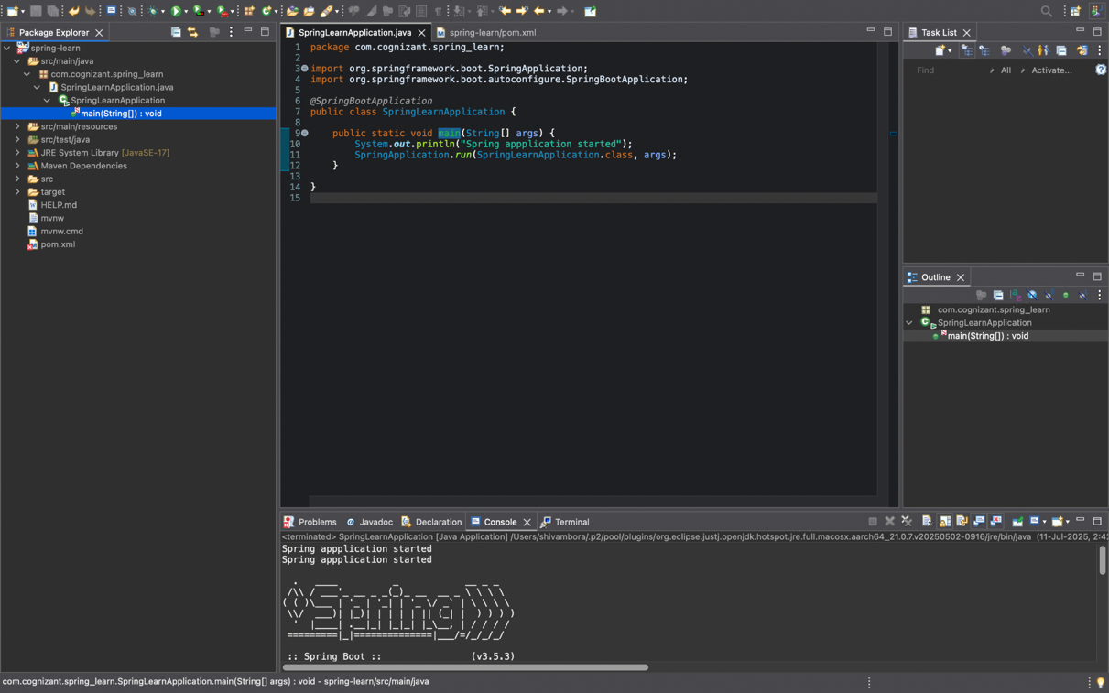

# Spring Core – Load Country from Spring Configuration XML

## 

## SpringLearnApplication.java

package com.cognizant.spring_learn;

import java.text.ParseException;

import java.text.SimpleDateFormat;

import java.util.Date;

import org.springframework.boot.SpringApplication;

import org.springframework.boot.autoconfigure.SpringBootApplication;

import org.springframework.context.ApplicationContext;

import org.springframework.context.support.ClassPathXmlApplicationContext;

*@SpringBootApplication*

public class SpringLearnApplication {

public static void main(String[] args) throws ParseException {

SpringApplication.*run*(SpringLearnApplication.class, args);

*displayDate*();

}

public static void displayDate() throws ParseException {

ApplicationContext context = new ClassPathXmlApplicationContext("date-format.xml");

SimpleDateFormat format = context.getBean("dateFormat", SimpleDateFormat.class);

Date parsedDate = format.parse("31/12/2018");

System.***out***.println(parsedDate);

}

}

# OUTPUT

